**Batch T7**

**Practical No. 6**

**Title of Assignment: Study and implementation of ReactJs**

**Student Name: Shreyash Patil**

**Student PRN: 22510039**

**Problem Statement 1: To-do List Application with State Management**This is the To-do page with no task:

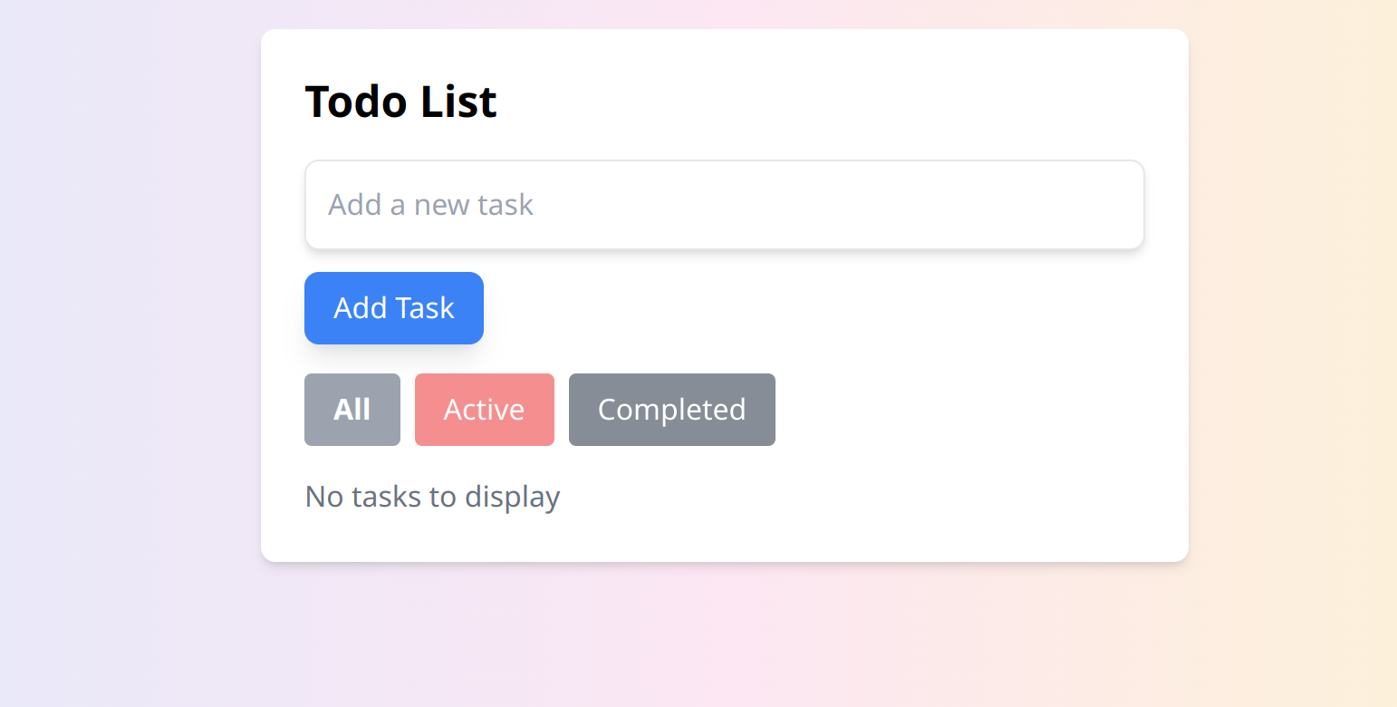

With task added

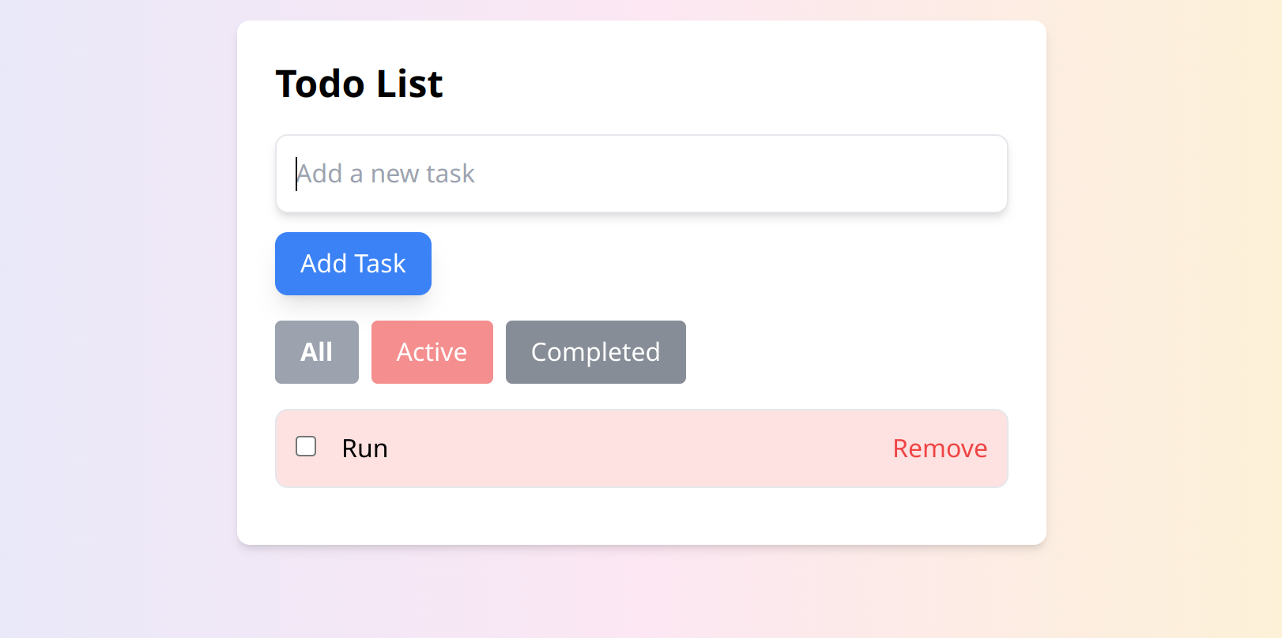

When its completed

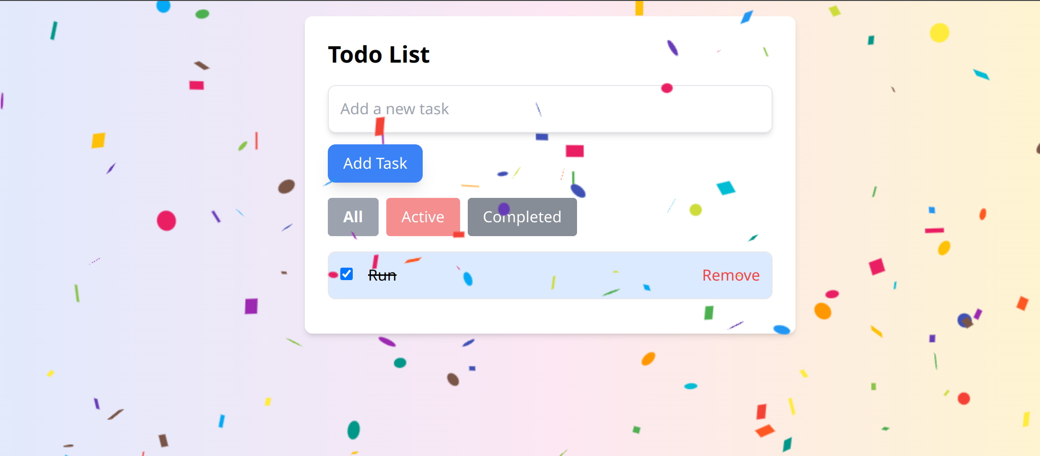

All the filtering buttons show active or completed tasks

Problem Statement 2: Simple E-commerce Cart System

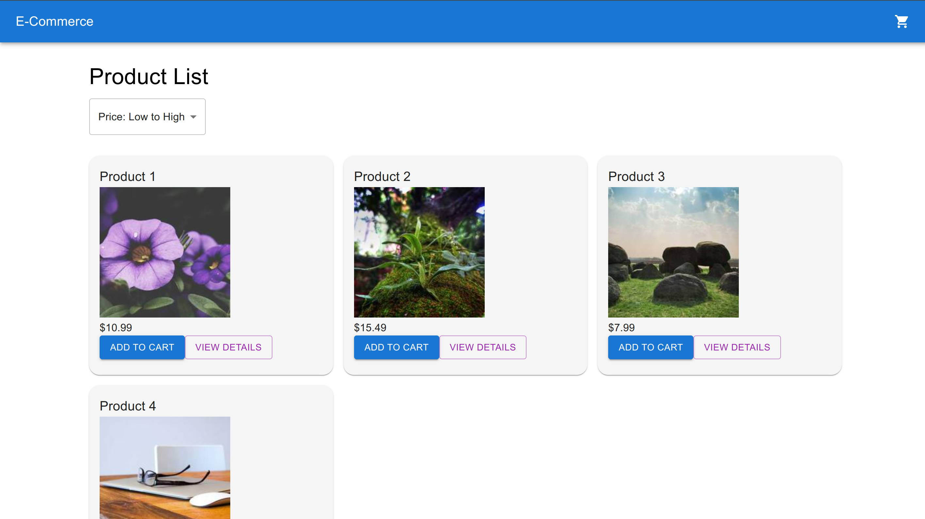

Cart page:

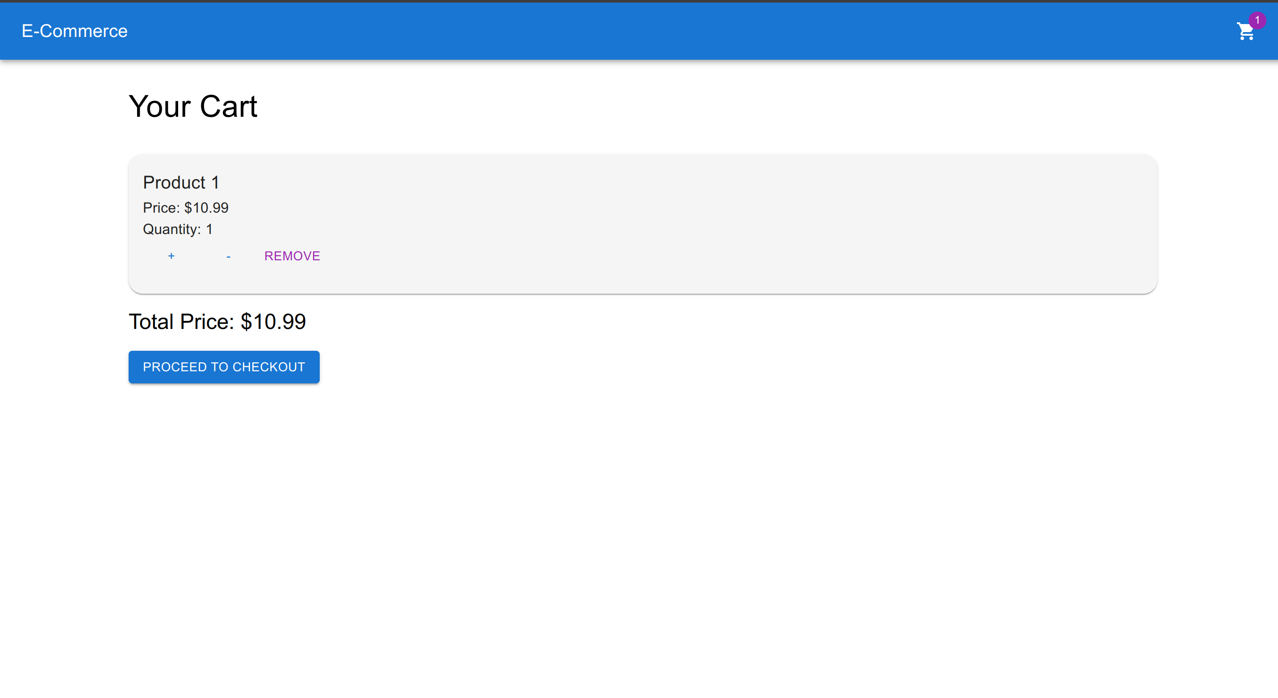

User Auth using Context api:

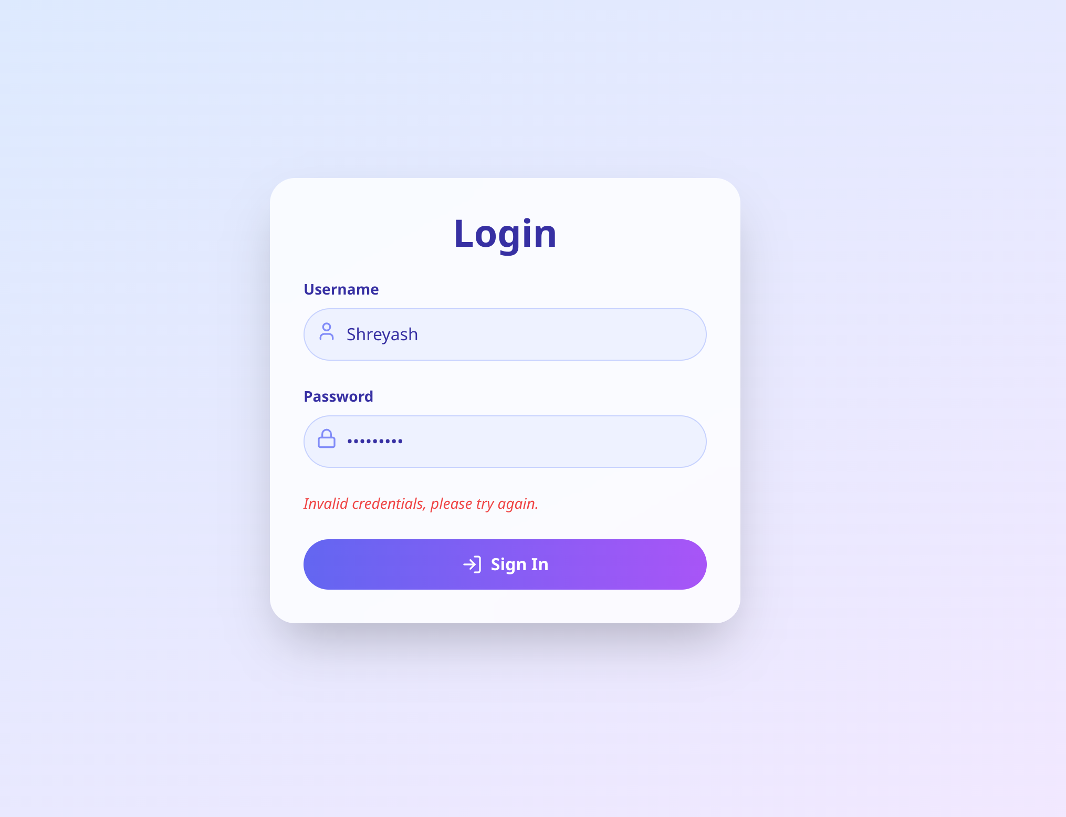

After successful login:

